IBM Chapter 5, Lesson 1 What is Marketing and the Marketing Mix

Section 5 – 1 Marketing Mix
Name:
Class Hour:

Objectives:
- What is Marketing
- What is Included in Marketing
- What is the Marketing Mix
- What is the 4ps of Marketing

Review: What is Marketing

Define Marketing

What are the Four Underlined words in the definition?

Marketing is about u customer n , d products that meet those needs, and marketing sure customers K about them and where to p them.

Marketing Includes:

Define In your own words what is a
want versus a need

Two Approaches of Marketing

Traditional Methods: | Digital Marketing
Definition: | Definition
Examples of Traditional | Examples of Digital Marketing:
Quick Write:
If you owned a business, do you believe you would use Traditional Marketing, Digital Marketing, or both methods? Explain why

The Marketing Mix

Define The Marketing Mix

Four Tools of Marketing: Enter the title in the circle, with the definition and decisions made in the boxes

Definition:

Key Decisions Made:

Definition:

Key Decisions Made:

Definition:

Key Decisions Made:

Definition:

Key Decisions Made:

Assignment: Table Talk Activity at Random Selected Table:

Four people to a group: The team of workers at your table will be drawn from a hat and you will move to a new location for the day. You will work as a team to answer the following questions. Create a Poster that will be shared in the class regarding the 4ps of Marketing:

What Business did you Draw

Name of Partners:

You will use the internet to find the answers and complete your table below. Each member will fill out the table in their activity packet. Once all your answers are filled in, create a Poster Board that you will hang in the class about this business and their 4Ps of Marketing. We will review, Starbucks, McDonalds, Subway, Apple, and Nike. Each group will present their board to the class. You will present your findings to the class with your poster board.

The Marketing Mix for Business:

Product

Price

Place

Promotion

After each group has completed their project. Review the boards created by each group. Select one additional business that they research and complete the details for that business below:
2nd Business: The Marketing Mix for Business:

Product

Price

Place

Promotion

Quick Write Activity: Compare the business that you researched in your group with the second business you reviewed in the second table. What were some things you see as different between these two companies regarding pricings and promotion?
Pricing: Promotion:

Section 5 – 2 Target Market
Name:
Class Hour:

Objectives:
- What is Market Segmentation
- What is a Target Market
- How to Target Market
- Why is Target Marketing Important

Review: What is the Marketing Mix:

The Marketing Mix

Define The Marketing Mix

The Four Ps of Marketing are:

4Ps of Marketing

Product | Definition:  Strategies:
Price | Definition:  Strategies:
Place | Definition:  Strategies:
Promotion | Definition:  Strategies
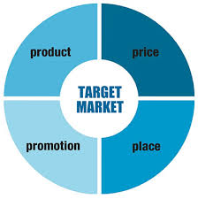
Who is the 4ps of Marketing Directed at?
- Is everyone in the world your customer?
- Your 4ps are directed at people most
likely to buy your product. These are your
CUSTOMERS and become known as your
Insert word in center also

The Target Market

Define Market

Define Market Segmentation

Define Target Market

Quick Write:
In your own words why do you think that Market Segmentation to find your Target Market is important
to businesses

Three Ways to Market Products:

- Mass Market

- Target Market Segmentation

- Niche Marketing

Most Common Ways of Market Segmentation (narrow to get a target market)
Common Characteristics used in Market Segmentation?

1 | 6
2 | 7
3 | 8
4 | 9
5

Work together at your table and try to build the answer for the following type of product:
Snowmobile: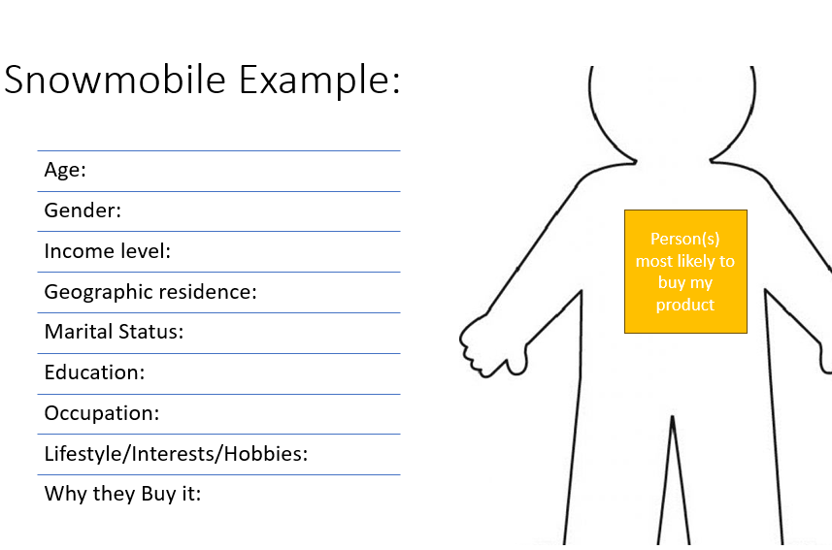

Benefits to Market Segmentation and Target Marketing:
Benefit | Brief Explanation

